A Mini Project Report on

## Expense Manager

Submitted in partial fulfillment of the requirements for the award of the degree of

### Bachelor of Engineering

in

### Computer Engineering

by

### Rakshit Shah(19102008)

### Tejas Sheth(19102026)

### Het Patel(19102005)

### Vikas Kumar Sethiya (19102028)

Under the Guidance of

### Prof. Mayuri Jain



#### Department of Branch Name

A.P. Shah Institute of Technology

G.B.Road, Kasarvadavli, Thane(W), Mumbai-400615 UNIVERSITY OF MUMBAI

#### Academic Year 2020-2021

i

**Approval Sheet**

This Mini Project Report entitled ***“Expense Manager”*** Submitted by ***“ Rakshit Shah ”(19102008),“ Tejas Sheth ”(19102026),“ Het Patel ”(19102005),“ Vikas Kumar Sethiya ”(19102028)*** is approved for the partial fulfillment of the requirement for the award of the degree of ***Bachelor of Engineering*** in ***Computer Engineering*** from ***University of Mumbai*** .



(Prof. Mayuri Jain)

Guide



Prof. Sachin H Malave

Head Department of Computer Engineering

Place:A.P.Shah Institute of Technology,

Thane Date:

### CERTIFICATE

This is to certify that the mini project entitled ***“Expense Manager”*** submitted by ***“Rakshit Shah” (19102008),“Tejas Sheth” (19102026),“Het Patel” (19102005),“Vikas Kumar Sethiya” (19102028)*** for the partial fulfillment of the requirement for award of a degree ***Bachelor of Engineering*** in ***Computer Engineering.***,to the University of Mumbai,is a bonafide work carried out during the academic year 2020-2021.



(Prof. Mayuri Jain)

Guide



Prof. Sachin H Malave Dr. Uttam D.Kolekar

Head Department of Computer Engineering Principal

External Examiner(s)

1.

2.

Place:A.P.Shah Institute of Technology,Thane

Date:

### Declaration

We declare that this written submission represents our ideas in our own words and where others’ ideas or words have been included, we have adequately cited and referenced the original sources. We also declare that We have adhered to all principles of academic honesty and integrity and have not misrepresented or fabricated or falsified any idea/data/fact/source in our submission. We understand that any violation of the above will be cause for disciplinary action by the Institute and can also evoke penal action from the sources which have thus not been properly cited or from whom proper permission has not been taken when needed.

———————————————

(Signature)

———————————————

(Rakshit Shah - 19102008)

(Tejas Sheth - 19102026)

(Het Patel - 19102005 )

(Vikas Sethiya - 19102028 )

Date:

#### Abstract

According to a 2019 paper by Sumit Agarwal, Pulak Ghosh, Jing Li, and Tianyue Ruan available on the Asian Bureau of Finance and Economic Research, the advent of digital payments has led to overspending, especially among Indians. While curtailing digital transactions isn't the answer, monitoring one's spending could definitely help.

With this aim in mind, we have planned a Java-encoded application to keep track of the user's daily, monthly as well as yearly debited and credited amount. The program would also feature a threshold that the user can set and adjust, spending above which would be notified to the user. On the backend, JDK 8 would be used for Java implementation, with MySQL service for database and JDBC to connect the database. The user interface is to be designed using Java Swing.

In conclusion, we intend for our program to be a financial management assistant, especially for the young and the millennial cluster. We believe that the app has the potential to be a success in the market, especially among the young and millennial dynamic.

# Contents

1. **Introduction** . . . . . . . . . . . . . . . . . . . . . . . . . . . . . . . . . . . . . . . . **1**
   1. Problem Definition. . . . . . . . . . . . . . . . . . . . . . . . . . . . . . . 1
   2. Objectives. . . . . . . . . . . . . . . . . . . . . . . . . . . . . . . . . . . .  2
2. **Technology Stack**. . . . . . . . . . . . . . . . . . . . . . . . . . . . . . . . . . . . .  **3**
3. **Benefits and Applications**. . . . . . . . . . . . . . . . . . . . . . . . . . . . . . . . **4**
4. **Project Design**. . . . . . . . . . . . . . . . . . . . . . . . . . . . . . . . . . . . . . .  **5**
   1. Front End. . . . . . . . . . . . . . . . . . . . . . . . . . . . . . . . . . . . 5
   2. Back End. . . . . . . . . . . . . . . . . . . . . . . . . . . . . . . . . . . . .  6
   3. Data Flow Diagram. . . . . . . . . . . . . . . . . . . . . . . . . . . . . . . 7
5. **Annexure A**. . . . . . . . . . . . . . . . . . . . . . . . . . . . . . . . . . . . . . . . . **8**
   1. Gantt Chart. . . . . . . . . . . . . . . . . . . . . . . . . . . . . . . . . . . . 8
6. **Bibliography**. . . . . . . . . . . . . . . . . . . . . . . . . . . . . . . . . . . . . . . . . **9**
7. **Acknowledgement**. . . . . . . . . . . . . . . . . . . . . . . . . . . . . . . . . . . . . **10**

**List of Figures**

4.1 Front End . . . . . . . . . . . . . . . . . . . . . . . . . . . . . . . . . . . . . . . . 5

4.2 Back End . . . . . . . . . . . . . . . . . . . . . . . . . . . . . . . . . . . . . . . . 6

4.3 Data Flow diagram . . . . . . . . . . . . . . . . . . . . . . . . . . . . . . . . . . . 7

# List of Tables

5.1 Gantt Chart . . . . . . . . . . . . . . . . . . . . . . . . . . . . . . . . . . . . . . . 8

# Chapter 1 Introduction

## Problem Definition

To create a Java-based Program for managing day-to-day expenses allowing the user to keep a track of his/her Debited and Credited Amounts on a daily basis, monthly basis, and even yearly basis. To Notify users if he/she crosses a threshold amount and thus helping them in maintaining their balance and Expenses in a particular boundary.

1

## Objectives

* The main purpose of the Program is to manage daily expenditure.
* The program will comfort individuals as they will not have to keep track of their penned expenses whilst having the fear of misplacing them.
* Expense Management automation is the means by which - a person can significantly track their expenses.
* Improve budget control, while calculating and monitoring personal expenses and have a clear picture of their credited and debited expenses in a report format

2

# Chapter 2 Technology Stack

* Programming language : Java
* Database : Mysql
* JDBC ( for connecting to Database )
* User Interface : Java Swing
* Tools :
  + NetBeans
  + Eclipse IDE
  + Visual Studio Code Editor

# Chapter 3

**Benefits and Applications**

The use of expense management software reduces the unnecessary effort of creating expense reports manually, collecting and verifying the receipts of each expense. It can eliminate all these non-value adding activities, reducing the manual expense reporting time by 90%.

Users do not have to remember and collect the receipts, but rather note them down in the Expense Manager. It will help the User to contribute to saving the environment, by going truly Digital, and hence reducing the use of paper to keep a track of the expense.

Users can compare the actual plan with the estimated plan and spend in the future accordingly. Maintenance and Generation of expense reports are quick and hassle-free.

Expense management program lets you track spendings on the go, set-up spending rules, and analyze reports that give you the kind of insight you need to cut down on expenses.

By using an Expense Manager, you'll get fewer “oh I lost my expense track” and end up with more real data about where your money goes.

# Chapter 4 Project Design

## 

## Front End

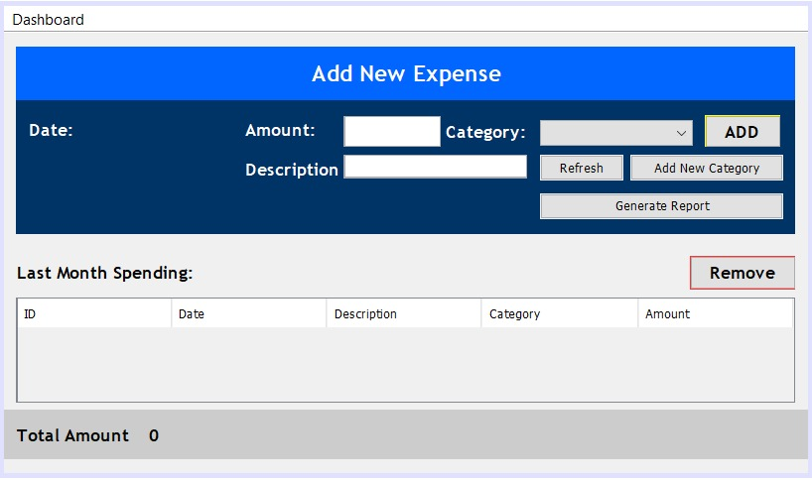

Diagram 4.1: Front End

## Back End

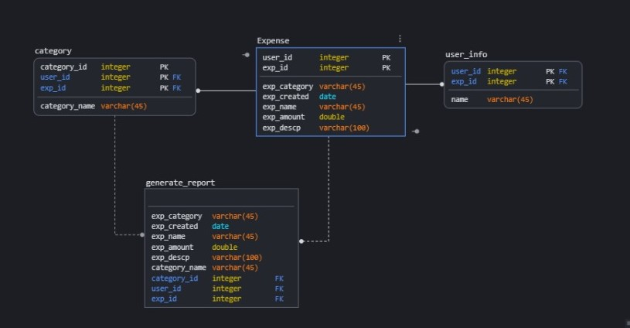

Diagram 4.2: Back End

## 

## Data Flow Diagram

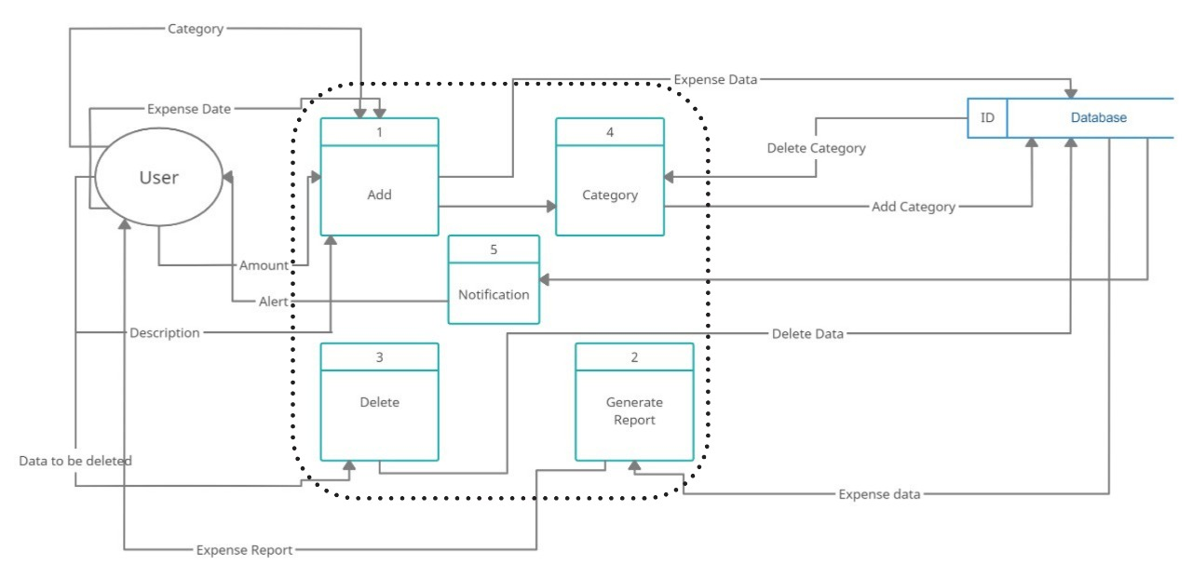

Diagram 4.3: Data flow diagram

# Chapter 5

**Annexure A**

5.1 Gantt Chart

# 

Table 5.1: Gantt Chart

8

# Chapter 6

**Bibliography**

### [Digital Payments Induce Over-Spending: Evidence from the 2016 Demonetization in India](http://abfer.org/working-papers/digital-payments-induce-over-spending-evidence-from-the-2016-demonetization-in-india/download)

### [[Sumit Agarwal (National University of Singapore)](http://abfer.org/working-papers/search-result?filter_tag=Sumit%20Agarwal%20(National%20University%20of%20Singapore)), [Pulak Ghosh (Indian Institute of Management Bangalore)](http://abfer.org/working-papers/search-result?filter_tag=Pulak%20Ghosh%20(Indian%20Institute%20of%20Management%20Bangalore)), [Jing Li (Singapore Management University)](http://abfer.org/working-papers/search-result?filter_tag=Jing%20Li%20(Singapore%20Management%20University)), [Tianyue Ruan (National University of Singapor](http://abfer.org/working-papers/search-result?filter_tag=Tianyue%20Ruan%20(National%20University%20of%20Singapore))e]

9

# Chapter 7

### Acknowledgement

We have great pleasure in presenting the mini project report on **Expense Manager.** We take this opportunity to express our sincere thanks towards our guide **Prof. Mayuri Jain** Department of Computer Engineering, APSIT thane for providing the technical guidelines and suggestions regarding line of work. We would like to express our gratitude towards his constant encouragement, support and guidance through the development of the project.

We thank **Prof.Sachin Malave, Head of Department**, Computer Engineering, APSIT for his encouragement during the progress meeting and providing guidelines to write this report.

We also thank the entire staff of APSIT for their invaluable help rendered during the course of this work. We wish to express our deep gratitude towards all our colleagues of APSIT for their encouragement.

#### Student Name1: Rakshit Shah

**Student ID1:19102008**

**Student Name2: Tejas Sheth**

**Student ID2: 19102026**

**Student Name3: Het Patel**

**Student ID3: 19102005**

**Student Name4: Vikas Kumar Sethiya**

**Student ID4: 19102028**

10